Description of the comic strip

The comic strip is supposed to look like an advert for the environmentally friendly app envim. It is supposed to look nice, a little goofy and have calming colors.

The app envim (name is in all lowercase) uses a green and white color scheme that is muted and calming to look at. Your comic should fit into this branding and therefore only use white, shades of green and the tiniest bit of light blue for the sky. In this document I will specify each of the pictures you should draw in this document and give screenshots from the app for reference, the text that should be featured in each picture etc.

Some of the pictures contain people. It is important to me that they don´t become to specific. They should stand for any user and don´t have specific personal features or genders. I want you to draw them all in white to signal that they have good morals and do something good. Therefore, most of the background should be in shades of green. Whenever you draw anything else, there should be a green hue to it unless specified otherwise.

Please arrange the 7 pictures like this:

To see roughly what I imagined, please look at this picture:

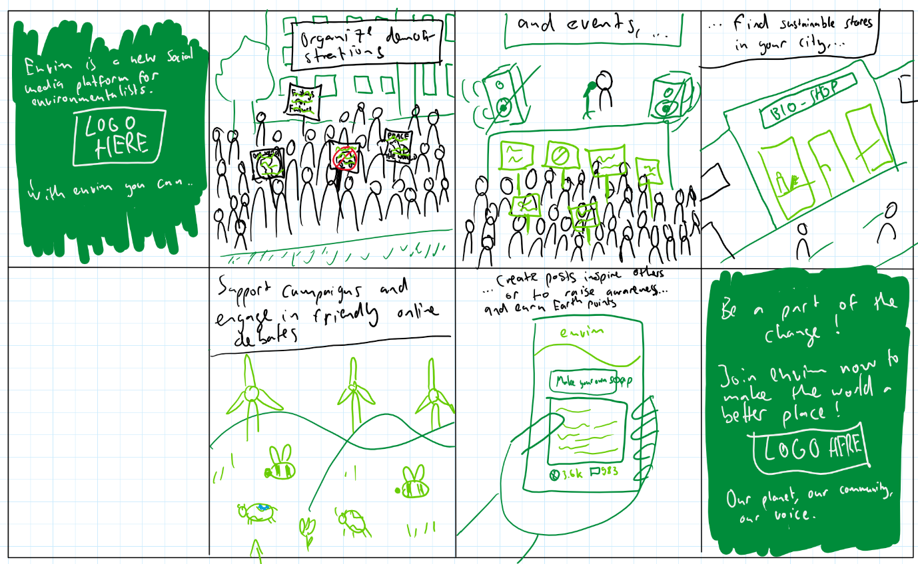I also send it to you as a bigger file. That is just a sketch and if you are in doubt always choose what I wrote in this document. It is more worked out than the sketch.

# Picture 1

Figure : For Picture 1 and 8

The first picture should resemble the picture shown on the right. I want you to redraw it a little more playful, as the background. Also redraw the logo. It does not need to be incredibly detailed but needs to be clearly recognizable, with softer corners.

Over the logo there should be the following text: “Envim is a new social media platform for eco-conscious people who want to make a difference”

Below the logo there should be the following text. “With envim you can …”

# Picture 2

Picture 2 features a crowd of people demonstrating for a good cause. A few demonstrates hold up signs. Each of them either features the envim logo (drawn) or the name “envim” always in lower-case

The demonstration takes place on a big street in a big city and office like building should be featured in the background. Keep in mind that all people are just white and not to be made out. When I say white I mean the color NOT the skin color. There should be no skin colors. Everything is drawn in green with white highlights.

The crowd moves from left to right.

There should be a text above, reading “Organize demonstrations …”

# Picture 3

Picture three features a stage, where a few crowd leaders hold a speech. There is a microphone and big speakers. In the background some scaffolding holding up the stage can be seen.

In front of the stage there is a crowd again. They hold up signs just like the crowd in picture 2 with signs of either the envim logo or the name. They all face the stage.

There should be a text above reading “… and events, …”

# Picture 4

Picture 4 features a common shopping street and the main thing in the picture is a bio shop. Please get creative and draw the store front, on the sign of the store name there should be a planet earth or recycling symbol. In front of the stores there are some people walking.

Everything is in shades of green. The people are white.

There should be a text above reading “… find sustainable stores in your city,…”

# Picture 5

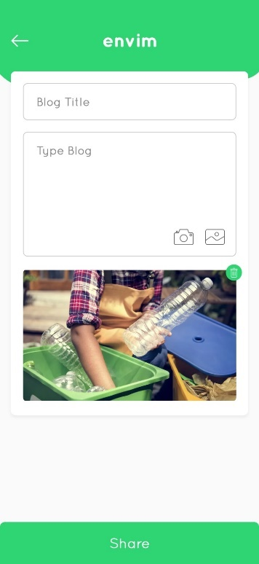Picture 5 shows a perfect world. There is a clear blue sky, but most of the picture is taken by hills with cows on it. The cows should have the pattern of the earth instead of normal cow patches. There are also flowers and bees (all in shades of green) and wind turbines that symbolize sustainable energy.

Figure : For picture 7

There should be a text above reading “…support campaigns and engage in friendly online debates…

# Picture 6

Picture 6 shows a cellphone that is held by a hand. Make the cellphone a dark shade of green. The screen of the phone should resemble this screenshot from the app shown on the right.

Put in “Creating your own soap” as blog title

Put in unreadable scribbling as the text below.

Draw a picture that fits to the post below.

It does not need much detail.

Please draw a good hand that holds the phone

Below, still on the phone screen there should be a little icon of the earth with a number next to it and a comment icon with a number next to it. The earth logo should look roughly like this: 

There should be a text above reading “and create posts to inspire others or to raise awareness and earn Earth points!”

# Picture 7

Picture 7 should resemble picture 1.

In the middle there should again be the envim logo in big.

Above the logo there should be the text

“Be a part of the change!

Join envim now to make the world a better place!”

Below the logo, in calligraphy, there should be the slogan “Our planet, our community, our voice”

Thank you a lot for your efforts!